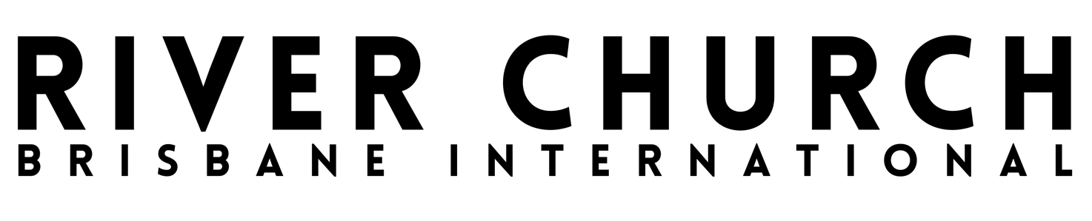
SAFE MINISTRY POLICY
Open your mouth, judge righteously, and plead the cause of the vulnerable and needy.
Proverbs 31:8-9

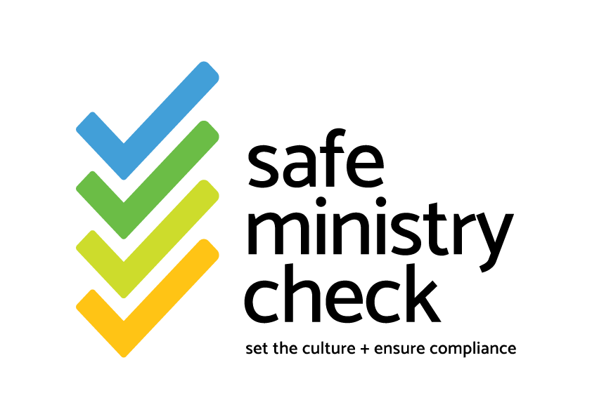

VERSION | REVIEW DATE | TEAM
V1 | 07/04/2025 | Samantha Horvat
V2 | 23/01/26 | Samantha Horvat

BACKGROUND & GOVERNANCE
The Leadership and Governance Body of River Church Brisbane has established this policy to express our commitment to safeguarding vulnerable people involved with River Church Brisbane.
This document outlines the underlying principles that guide our approach and the strategies being implemented to embed a safeguarding culture in the organisation at all levels. Because of the changing nature of our world and our organisation, we commit to regularly reviewing and updating this policy to ensure its ongoing effectiveness, relevance and fulfilment of any State and Federal laws to protect children and vulnerable people.,

1. Commitment to safeguard vulnerable people
We are committed to the biblical call to actively prevent harm and abuse, and ensure the safety and equity of everyone involved in our organisation with special concern for vulnerable people who face a higher risk of mistreatment. This includes children and young people, Aboriginal and Torres Strait Islanders, the elderly, people with disabilities, and people with identity and mental health challenges.
It is important that all people involved in our organisation (including vulnerable people and children) are informed about their rights, invited to express their individual needs, participate in decisions which significantly affect them, and have their concerns taken seriously. We also want families and communities who are involved in our organisation to be informed and involved in promoting the safety and wellbeing of vulnerable people. All people are encouraged to appropriately express their cultural backgrounds and racism will not be tolerated within the organisation.
To help achieve this, we encourage every person attending or involved in our organisation to complete the River Church Brisbane Safe Ministry Members Safeguarding course at
https://demo-jn9v.safeministrycheck.com.au
We have also made this policy (and further information for children, families and vulnerable people) available through our statement page, accessible online through a badge on our webpage
https://demo-jn9v.safeministrycheck.com.au/statement
This material will help people in our community to better understand their shared responsibility to safeguard vulnerable people around our community and how to raise any concerns. We actively encourage everyone involved in our organisation to be involved in the effectiveness and ongoing improvement of our policies and safeguarding procedures.

2. Commitment to respond to concerns
We are committed to creating a culture where people feel safe and encouraged to raise concerns about their own or other people’s safety.
Therefore we encourage people at all levels of the organisation and in our community to report any concerns they have about the safety and wellbeing of people connected with River Church Brisbane. We are committed to listening well and handling all concerns seriously. We will protect the confidentiality, dignity, health and well-being of all individuals involved in any concern raised. Any child-related issues will be managed with a focus on the interest of the child.
All reports will be managed by the River Church Brisbane Safe Ministry Contacts.

Safe Ministry Contacts
1. Ps Samantha Horvat:
Ph: 0422 091 398
Email: samantha@riverchurchbrisbane.com.au
2. Ilona Bernier:
Ph: 0422 402 114
Email: bananasunsets@gmail.com
The Safe Ministry Contacts are a sub-committee of the River Church Brisbane Leadership and Governance Body. When any concerns or allegations are raised, the Safe Ministry Contacts will follow the Safe Ministry Incident Management Process which, depending on the circumstances, may involve reporting the concern or allegation to other entities like the Police, the relevant State Child Protection body, and the insurer of River Church Brisbane. In certain incidents the Safe Ministry Contacts will appoint an Independent Ministry Investigator to investigate allegations.

3. Commitment to screening and training
We are committed to ensuring all leaders at River Church Brisbane are appropriately screened, supported and trained.
This means all board members, staff members, team leaders and volunteers involved in personal/relational serving roles (including anyone working with or around children) must follow the direction of the Safe Ministry Contacts who oversee this compliance. These leaders must:
- Be regular participants at River Church Brisbane.
- Provide referees who can confirm they are suitable to work with vulnerable people;
- Complete an approved safe ministry training course which outlines appropriate behaviour, including how to minimise the chance of harm, as well as training in how to identify and report cases of abuse (this can be completed at https://demo-jn9v.safeministrycheck.com.au);
- Commit to the River Church Brisbane Code of Conduct, including being willing to be held accountable for their behaviour; and
- If they are working with children & youth, they must have their state-based “Working With Children Check” verified and current.
No-one with a criminal record of child abuse, molestation or similar offences is allowed to be involved in children, youth or any other ministry leadership at River Church Brisbane.

4. Commitment to safe and accessible programs
We are committed to ensuring that our physical and online environments promote safety and wellbeing for all involved. Careful consideration will be given to the activities chosen, the venue, safe ratios of supervision, appropriate toileting practices, transportation, work health and safety, parental or guardian permission and confidentiality of records kept.
The Safe Ministry Contacts will regularly check-in on River Church Brisbane programs and team meetings to help establish a safeguarding culture and provide ongoing training and supervision to leaders and volunteers in those roles.
Date Instituted by Governance Body: 08/04/25
Date of Last Review by Governance Body: 23/01/26

Governance Body
A Governance Body is a group of people that has the authority to exercise governance over an organisation or entity. Examples of a governance body in your organisation may include the pastors, elders, committee or board members.
Organisation: An organised group of people with a particular purpose. Your faith based organisation may be a church, mission organisation or ministry group.
Safeguarding: Safeguarding is protecting the welfare and human rights of people that are, in some way, connected with your Organisation or its work – particularly people that may be at risk of abuse, neglect or exploitation. As such, safeguarding is part of your organisation's primary duty of care.
Safe Ministry Policy: Statements that set expectations for decisions made, or actions taken by, members of an organisation related to the protection of rights of vulnerable people and the duties of, as well as the terms and conditions of engagement for, organisation members & volunteers.
Safe Ministry Contact: A Safe Ministry Contact is someone in your organisation who will hear your concern, and help you work out what to do.
Incident Management Process: A document that outlines the process of and assists Safe Ministry Contacts in responding appropriately to concerns raised.
Vulnerable People: While the term ‘vulnerable people’ includes everyone under the age of 18, the elderly, people with disabilities, people who experience mental health issues, people who are unable to live at home, people who identify as lesbian, gay, bisexual, or transgender, people who are intersex, as well as people of Aboriginal and Torres Strait Islander descent.

National Principles for Child Safe Organisations, point 1
National Principles for Child Safe Organisations, points, 9 & 10
This policy is in accordance with the NSW Children and Young Persons (Care and Protection) Act 1998 No 157.
As an organisation that works with children, we are committed to the National Child Safe Principles. See https://childsafe.humanrights.gov.au/national-principles
National Principles for Child Safe Organisations, point 4
National Principles for Child Safe Organisations, point 2. Victorian Child Safe Standards, point 5
National Principles for Child Safe Organisations, point 3
Victorian Child Safe Standards, point 1
National Principles for Child Safe Organisations, point 8 & 3.
National Principles for Child Safe Organisations, point 6
National Principles for Child Safe Organisations, point 10
National Principles for Child Safe Organisations, points 5, 7 & 8
National Principles for Child Safe Organisations, point 8
National Principles for Child Safe Organisations, points 1, 7, 8.

